**Chapter I**

**The Problem and its Background**

As technology continues to advance, computers are becoming more part of everyday life. Computers are everywhere at work, at school, and at home .Many daily activities either involve the use of or depend on information from a computer. This maybe because computers are used in almost every field and profession like education and office works to perform large number of computer application .It also the best solution for providing information and a way of communications in every individual and gives better understanding of some events that can arouse the interest of some particular subject matter. The computerized world is a highly efficient one, which processing the big quantities of data and keeping .The extensive records will not be a problem to a post industrialized society, likewise the unreliable and slow processing and preparing student record and enrollment summary of report.

In the field of education, researchers and theorists have focused intensively in recent years on examining the concepts and use of information in to assist administrators, teachers, students and parents. Schools, like any other organization used to manage all sorts of data and information to ensure attainment of its goals and objectives. The emerging needs in most schools for accurate and relevant data and reliable information strengthen the student information especially in enrollment processes.

Now, Interest in using cloud computing as a Platform as a service in enrollment has grown due to the advantages of greater flexibility and availability in obtaining computing resources at lower cost. Many of the features that make cloud computing attractive, however, can also be at odds with traditional security models and controls. The primary purpose is security and privacy consideration involved in the enrollment of the students’ information in public high schools.

Cloud computing has been defined by NIST as a model for enabling convenient, on-demand network access to a shared pool of configurable computing resources (e.g., networks, servers, storage, applications, and services) that can be rapidly provisioned and released with minimal management effort or cloud provider interaction. Gartner (2011) defined cloud computing as “a style of computing where massively scalable IT-enabled capabilities are delivered ‘as a service’ to external customers using Internet technologies”.

The main features of the cloud rapid elasticity, measured services, on demand self services, everywhere network access and resource pooling.

The cloud makes it possible for the schools to access student enrollment information from anywhere at any time. While a traditional computer setup requires being in the same location as data storage device, the cloud takes away that step. This infrastructure consists of data centers that are monitored and maintained around the clock by content providers.

One requirement is that schools need to have an internet connection in order to access the cloud. This means that if administrators want to look at a specific document or information that is being housed in the cloud, they must first establish an internet connection either through a wireless or wired internet or a mobile broadband connection. The benefit is that they can access that same document from wherever they are with any device that can access the internet. These devices could be a desktop, laptop, tablet, or phone. This can also help the schools to function more smoothly because anyone who can connect to the internet and the cloud can work on documents, access software, and store data. This is the freedom that the cloud can provide for the high school students and for the public schools handling the enrollment process.

Inspired by these cloud services, the researchers came up with a cloud based enrollment system for the Bambang National high schools. The school has adapting the k to 12 which means that 1st year, 2nd year, third year and fourth year are now called us Grade 7-10 and Grade 11 and 12 is known as the senior high School. The study considered the prevailing process of the school and how this process can be modified for having a more efficient and effective enrollment system. One of the factors considered in designing the proposed system is the lack of manpower to accommodate all enrollees. Also considered are the tedious task of filling out the application form and the inaccuracies of information provided by the students. These factors cause enrollment delay, which is disadvantageous to the enrolment personnel and the enrollees. Since the study involves proper records handling, tracing the constraints and evaluation of the manual system is essential. Thus, the researchers gathered data necessary in the enrollment system, which is designed to benefit the schools, teachers, and students and especially school administrators because they can access and manage information directly and conveniently.

**OBJECTIVES OF THE PROJECT**

**General Objectives**

The main objective of the study is to develop a Cloud Based Enrollment System of Bambang National High School.

**Specific Objectives**

1. To lessen the workloads of the administrators and Faculties.

2. To minimize the time and effort of the students during enrollment season.

3. To develop an accurate and easiest way of enrollment of the students of Bambang National High School by accessing it into the internet.

4. To provide the user friendly enrollment website in managing olds students, new student and transferees.

**SCOPE AND LIMITATIONS OF THE PROJECT**

**Scope**

* The cloud based enrollment system is a portal type that covers the major processes in the enrollment system, namely registration of the new students, enrollment of old and new students, files maintenance such as list of enrolled students in different year level in public high schools.
* Administrators have total access to the system, confirmed the students who are officially enrolled and generate or print records of the students, search student id number, viewing subjects, editing student records.
* The system give furthermore information’s about the enrollment process such as to know how many students are enrolled in every year level.
* The old, new, transferees’ students with the following services: register into the enrollment form in the online enrollment website, viewing assessment fees, choose subject they want to enroll, input grades in every subject.

**Limitations**

The system does not cover the computation of student’s grades, class scheduling, viewing of teachers and paying of fees. Not accepting any online payments. It can only operate for high school enrollment purposes. It can’t show the schedule of the subject in per year level.

**SIGNIFICANCE OF THE STUDY**

The significance of the study would justify the need to conduct the study. It should specify the grouped of people who will benefit from the study and description of how these people will be arranged according to who should benefit most.

**Freshmen, transferees, Old.** The study will also help students to be knowledgeable enough on entering the information technology fields as applying the lectures to actual performances and to inform them of an easy way of processing enrollment. It will give them also a background and become more advance and be familiar on having a new way of enrolling.

**Faculty.** In this proposed system, it will help them to lessen their work and less consumes time in handling the enrollment process for the high schools. It help them to minimize the effort and time exert in terms of gathering the data or information of the students.

**Administrators.** The result of this investigation would serve as a benchmark for them to make an easy way handling the student records during the enrollment. It will help to lessen their work and help them also to have a fast way of enrolling students as well as in securing their student information.

**Future Researchers.** This study would serve as a handy reference for the other researchers who would embark on a similar study. In the future especially on certain aspects not derived into by the present.

**Chapter II**

**REVIEW OF RELATED LITERATURE AND STUDIES**

The Literature and studies cited in this chapter tackle the different concept, understanding, and ideas, generalization or conclusions and different development related to study of the enrollment from the past up to the present and which serves as the researchers guide in developing the project. Those that were also included in this chapter helps in familiarizing information that are relevant and similar to the present study.

**THEORETICAL BACKGROUND**

Enrollment management is “not just an organizational concept: it is both a process and a series of activities that involve the entire campus” (Hossler & Bean, 1990).

Dennis defines enrollment management as forecasting trends that will affect higher education and utilizing research to plan for the future (Dennis,1998). Second,Dennis lists the following attributes of those who understand enrollment management. Hossler and Bean conclude that there are two goals of enrollment management. “First, to exert more control over the characteristics of the student body, and two control the size of the student body” (& Bean, 1990, p.5).

Given these two perspectives, one would say that enrollment management is concerned with the attraction and retention of students (Braxton, Vesper, & Hossler, 1995). Donhardt (1995) feels that enrollment management involves the

influence of the whole enrollment picture from recruitment through graduation. Bateman and Spruill (1995) found that enrollment management extends to the educational outcomes of attendance.

Hossler and Bean (1990) define enrollment management as “efforts to influence the characteristics and the size of enrolled student bodies by directing the activities of the offices of admissions, financial aid, new-student orientation, career planning, retention, and a number of other student affairs areas” (Dennis, 1998). Tinto and Russo (1994) report that the success of enrollment management programs has been only moderately successful.

In traditional way of enrolling, manual enrollment system is commonly used as a way of enrolling students to the schools public and private high School and is continuing to be used nowadays. In manual way of enrolling students they must have to fill up first using ball pen and an enrollment form sheet given by their teachers. By the help of different developers, programmers they have develop different system about the enrollment process. Computerized and online enrollment systems that helps the school for having an easier process of enrolling.

**Related Literature**

According to Aquino (2005), importance of computer application is increasing day by day. In the latest decades of the Millennium winning organization are those which are willing to integrate business strategy and computer information technology in plying their respective trades. The use of computer information technology results for them to be able to develop products fast and make decisions fast, ability to have fluid organization structures, able to cope with the demanding work force and external environment by the rapid development of innovative approaches and lastly using information system confirms the company’s mission vision. Schools use information systems in the way of implementing an enrolment system. This results for them to attract enrollees and earn an income. Enrollees are attracted because the use of the said system makes the transactions faster and easier.

“Lack of enrolment system in schools can lead to chaos and troubles”, as stated by Ace Adrian (2011). Students will be confused on what they should do to be able to enroll that is why such systems is extremely useful in the way that it gives an ease on working on enrolment processes. Enrollment is very useful in retrieving vital information of the students. Without it can lead difficulty both for the administration of school and student in enrollment processes

Many countries nowadays, especially the developing nations are challenged by the rapid technological changes. This has radically changed the living and working styles of the entire society. This transformation has been driven partly by rapid technological innovation. While in the 20th century saw the rise of the industrial revolution with steam-powered machines intensifying and expanding human productive power, the 21thcentury was characterized by the birth of machine-powered flight and the emergence of broadcasting and computer technologies the extend the reach of human creativity even more and made possible new ways by which humans could live and work together (Tinio, 2002).

The transformation of manual enrollment transaction to automate and now into a web based automation is one example of what has driven partly by the rapid technological innovation. Any ways just to make work easier and faster like enrollment transactions is possible with the emergence of computer technologies.

Technology innovation had influenced man’s work from data processing, business transaction, research, planning, monitoring and even in medical operation on human anatomy are now entrusted to computer technology. Web applications are popular due to ubiquity of its applications. The ability to update and maintain web applications without distributing and installing software on potentially thousands of client computers are key reasons for its popularity. A significant advantage of building web applications to support a standard browser feature is the ability to perform as specified, regardless of the operating system installed on a given client (Bacala &Reanno, 2009).

**Web-Based enrollment system**

A web-based enrolment system has featured that meet most of academic institutions system’s needs and requirements. This includes standardized modules for student registration, enrolment, grade management, and other modules that are deemed necessary to operate a school.

According to Jennifer Rowley (2005), information systems are a tool to support information management. Information systems are increasingly being used in organizations with the objective of providing competitive advantage. The information systems used by organizations can be grouped into different types such as transaction processing system, management information system, decision support system, executive information system, expert systems and office information system. Information Technology has heralded the advent of the information society. The information society may be a „virtual society‟. The concepts of the electronic classroom, the electronic office and electronic library have been explored. Information system poses a number of issues on society in general, including: changing employment patterns, archiving, and bibliographic control, security and data protection, intellectual property, marketplace issues and access.

An enrollment system is basically included in one of the classification of information system that is stated by the author, thus it serves a tool to support information management with regards to the student data, enrolment fees information and other with a connection to the enrolment process. Every school gain competitive advantage of having this system for they will have the capacity on handling important information at ease and with security. The iterative implementation approach is a theory that eliminates problems of using a waterfall study. This is invented to avoid a linear and sequential development of study. The overall functionality of the system is broken down into feature sets. These features sets often based upon use cases from the analysis stage, containing group of individual features that are related, typically by a functional area (Stephen McHenry, 2010)

WAMP5 (WAMP means Windows Apache Mysql PHP) is a platform of Web development under Windows. It allows you to develop dynamic Web sites with Apache server, PHP5 script language, and the database of MySQL release 5. It also possesses PHP MyAdmin and SQLite manager to manage more easily your databases.

Windows 7 is an operating system produced by Microsoft for use on personal computers, including home and business desktops, laptops, netbooks, tablet PCs, and media center PCs. It was released to manufacturing on July 22, 2009, and became generally available for retail worldwide on October 22, 2009,less than three years after the release of its predecessor, Windows Vista. Windows 7's server counterpart, Windows Server 2008 R2, was released at the same time. Windows 7 is succeeded by Windows 8.

Adopting the theory of Stephen McHenry which is known as the iterative implementation covers the breakdown of overall functionality of the system to a what he called feature set and those feature sets represents different process involve in an enrollment system. It helps locate what feature an enrollment system will have since that this kind of systems does many activities and processes.

According to Dunn and Scott (2005), science and technology is the root of emerging innovations in this world. For many years now, a person in this field of expertise does not stop to reshape the landscape of today’s business world.

Enrollment system has made huge impact into the school arena. It is a system that is built on innovative program strategies. It is a system that will help both the enrollment personnel-in-charge and the students to easily process the enrollment at a lesser time. Distinct from traditional enrollment, LAN enrollment system process large assortment of student records and provides efficient and consistent information services.

As stated by Holmes (2006), “The Internet is neither an extraordinary communication tool nor revolutionary. It simply represents the current stage in the development of human capabilities through written language, which itself derived from the spoken form.” That statement only shows that advancement in modern technology is at their highest peak. Nowadays, Web-based applications are widely used due to their ubiquity.

Web-based enrollment system is currently emerging on markets for they are offering transaction convenience and service efficiency through the use of Internet. This system becomes a powerful tool in dealing with information management regarding enrollment transactions.

According to Forman(2007), continuing innovation in technologies can lead to organizational changes that range from improvement of day to day operation and for easy access it provides for the end users. Many schools today have adapted this innovation in offering of their services.

Tinn (2001) stated that the computerization responded to the call the office or any workplace to help their daily operation. Malolos et.al (2002) stated that the study of automation is important in the sense time that minimizes the time and effort normally exerted in manual process. Janes (2001) stated that computers are extremely reliable device and very powerful calculators with some great accessories applications like word processing problem for all of business activities, regardless of size, computers have three advantages over other type of office equipment that process information because computer are faster, more accurate more economical. Reyes (2005) task would be time consuming to accomplish manually and more practical with the aid of computers field in cabinet.

**Automation using computers**

According to Flores (2002), the automation is described simply as the substitution of machine control of human. Dioso (2001) stated that computer assist careful intelligent planning, organizing, actuating and controlling .This maybe observed from the past that they monitor production activities, solve scientific problem and help arrive in tentative answer to a multitude of involve conditions. Ralph M. Stair (1999) emphasized that the development of technology through the years have enabled us to do more with less effort. From the orientation of the light bulb to the industrial revolution and beyond, we have continuously tried to in a more efficient means of doing tasks. Lewis (2002) stated that the reason for using computers vary from person to person. Some of the computers in business are to perform accuracy, to be as productivity, to decrease bottle necks or hassles to alter cash flows or to simples elevate your status. SybexInc (1999) stated that visual basic provide a graphical environment in which the users usually designed the forms and control that become the building block of tour application . Visual Basic support many useful tools that will help the user more productivity. Gold Chager et al (2003) said that computer as a device for processing information knew computer plays a significant role in their lives, but few are aware of just how pervasive role is. Mane (2000) mentioned that the creation of the computer made the easier to accomplish that by doing it manually, to have the direct access on straightforward answer just monitoring record where in the needs of computer make possible for everyone to get data in a particular need. We can consider that the computer is necessary and its productive tool for individual. Gurewich (1999) stated that the database system makes the work faster for every institution. For the mere fact that instead of doing things manually, with the use of computer technology everything is done fasters.

**Computer- Based Enrollment system**

Halili, M.C.N. (2004) that man’s actions are just involuntary movements especially when time allow to plan his next action. These responses pass through the process of reasoning and analysis. Huntchinson et.al (2001) stated that file is a collection of related records. Examples are the entire student’s courses card for Anthropology 101 or the transcript of all courses in the register’s office. Bryan (2006) emphasized the information system is a set of people, procedures and resources that collects, transforms and disseminates information in an organization to do’s ends rely on many types of information system (IS). They might include simple manual information system and informal system and also computer based information system that uses hardware, software telecommunication and other forms of information technology (IT). Sander (2002) computers are an intelligence amplifier that can free human to use their time effectively. Because a computer is a fast and accurate electronic symbol or data manipulating system that design automatically accept and store input data process and procedure output results under the direction of the stored program or instruction. Tows and (2005) stated that database is instructed collection of data. The data may be about people, product events in short, any type of information is to manage the collection of data for reporting and making decision. Adamski (2007) give some advantages of database processing first economy of scale getting more information from some amount of data, sharing data balancing conflicting requirement, enforcement of standard, controlled redundancy consisting integrity security ,flexibility and responsiveness ,increase programmers productivity, improve program maintenance and data independence Perkins (1999) stated that computer has an impressive impact upon business, governmental organization; bank and all sorts of organization and on how they are operate and manage. Alcaria (2004) explained that the use of computer are continue to grow, the need for a more timely information and data processing comes on demand keeping the records of any manual operations need the application of computer because handling it manually will only be conflicting. Kroenke (2002) in the early 1970’s database processing was considered an esoteric subject of interest only to the longest corporation with the largest computer.

**Information system-Database System Concept**

Today, database processing is becoming an information system standard. Silberschatz (2006) in his book “” the goal of database system is to simplify and facilitate access to data. Ahitud et.al (2007) Mentioned that information system are more collection of hardware, software and people. They should be constructed to fit the organization’s strategy and structure so that it could easily be adapted to the information they needed. Asumbra (2002) Access to information is the best way to. In line with technology access to information within fingertips is the easier way to be equipped in the future. Hammer (2003) Said that computer could eliminate the need for copying and rearranging information, which was entered into system. They also perform mathematical computation; in short computer can eliminate most of the paper works. Microsoft Corporation (2002) Explained that computer network are collection of computer and intelligent peripheral equipment that are inter connected by telephone lines, micro wave relays and other high-speed communication links of the purpose of exchanging data and sharing equipment.

**Cloud**

Important Feature of Cloud Computing ([Florence](http://www.cloudtweaks.com/author/florence/)*,2012)* inCloudComputing, [Computing](http://www.cloudtweaks.com/category/computing/), [Host](http://www.cloudtweaks.com/category/cloud-computing-host/), [IT](http://www.cloudtweaks.com/category/it/), [Security](http://www.cloudtweaks.com/category/security/), [Technology](http://www.cloudtweaks.com/category/technology/),TrendsImportant Features of Cloud Computing. Since the inception of Information Technology. Information Technology has provided various types of services which are secure, reliable, and available every time. In order to obtain the highest quality cloud computing, business owners have turned to its characteristics and features in order to acquire this service.

A key characteristic of cloud computing is its quick scalability. Upgrades and changes to the services are done instantaneously and easily enabling the cloud computing service to be resilient. It is use for data storage, processing speed.

**Related Studies**

Based on the researcher, a web-based enrolment system for Veritas Parochial School (VPS) in Web Based enrollment system, Manila was developed to help its students enroll in a more efficient way without the hassles of waiting long hours in filling out forms, which sometimes become redundant, or to stand in line and pay at the cashier. It is with the Web-based Enrolment System for VPS that this new style of enrolment may be achieved. This new type of system offers its students new options for enrolling at VPS. By logging on to VPS website, one can register and enroll subjects for a school year. With these, all the students are required to fill out certain forms that do not take more than a few minutes to accomplish. The system stores its records in the school database for future references.

Confirmation of the transaction made by the students need to be verified, the payment of tuition fees must be made in the schools registrar. The students may also browse the web site of VPS and he can check his current account. He can also refer to the list of the school current tuition fee rates (Pascual&Riceo, 2008).

According to the project study in 2005 by Mr. Lopez, an enrolment system help and provide efficient and reliable services to the students, enrolment personnel and administration. Moreover, this system improved the process of enrolment in terms of searching, retrieving and subject schedules.

In a study conducted by Cayabyab (2007), many problems and difficulties were identified in the existing system of Dagupan City National High School (DCNHS). These major concerns are affecting the efficient enrolment system of students. Security of the students records were found to be at high risk. The current system may fail to protect some important documents. It has also untimely and inefficient report generation. A computerized system for DCNHS shall result to a significant increase in the number of enrollees.

**Network-Based Enrollment system**

Conde (2007) in his study entitled “Network-bases Enrollment System of Paete National High School cited that the manual process of enrollment and manual handling of information and reports of the students is very laborious one. The proponents developed a network based system enrollment system to the said school to solve the huge amount of task.

Garcia (2002) created the “LSPC Enrollment System”, the study can be a great help to persons concerned during the enrollment period, the registrar, instructor of the students as they retrieval necessary information when needed and lessen the burden manually browsing over enrollment slip for record purposes Saayo et.al (2008) developed the system “Network based automated Enrollment and grading system for Morong National High School. Due to increasing population of the institution, and the school currently implementing the manual system, every student spends a lot of time during enrollment period, such as paying their tuition fees and processing the school requirements. Valina et.al (2009) entitled “Network-based student Permanent Record keeping and Enrollment System of Balian National High School”. This System was made to lessen the time and effort exerted by both student and school employees. It is also made to give accurate reports and keep records of every students every students and for easy and fast way of enrollment. Soria et.al. (2006) constructed a system entitled “Network-based Computerized inventory System for the supply office o the LSPC main campus. With the advancement of technology, devices and machines were improve , developed and inverted to cope up with the need of new world. There are different systems designed for reliable, efficient and very useful to the user. Cabanget.al. (2003) developed the ‘computerized Students Record Monitoring System of Siniloan National High School”, Computerized Student data will be exceedingly helped to the user through continuous management of the School. It could help the registrar for a less effort services in the institutions especially in updating, printing and deleting student’s record. Velasco (2002) Study entitled “Maulawin National High School Student Information System” cited that maintaining students, records manually is a very difficult task and time consuming. In that case, computerization system that can help and handle 17 this data needed to speed up the process of student’s record keeping and to promote and reliability.

Curaet.al. (2004) Designed system entitled “computerized inventory system of office of the supply in LSPU” is capable of handling voluminous data about the flow of item insurance and reply to the flow of items’ issuance and return in supply office Torres et.al. (2002) conducted a study that resolves around the importance computerization of student information. This study was conducted with the hope that it would help minimize time and effort in processing student’s information in Maulawin National High School. The basic feature of this study is after the storage and access of retrieving and updating the data. Alcaira (1999) Stated that the using of computer are continue to grow, the need for a more timely information and data processing comes on demand keeping the record of any manual operations need the application, because handling it manually will only be conflicting. Araviaet.al. (2002) Show the growing importance of computers in the society. The significance of the study revolves the automation of student permanent record keeping. Garnace (1999) Developed application software for the computerized information system of a commercial piggery using the concept of the database and implemented it in database.

**Automation Enrollment System**

Gumitao (2001) System is designed to provide reports of the list of enrollment per school year, periodical grade of students, and list of new, old and transferees Revalla (2005) created an Automation Enrollment System for the computer Science Department of the Laguna College business and Arts. The study was conceived because of the need to update the current registration system of LCBA, which is done manually. Her study, was based on the special problem of Mr. Bonifacio E. Bacani, Jr. about “Student Record information System”. Kampitan (2000) developed an Enrollment System of Liceo De Victoria that is designed to keep the students records. This is used to provide an effective and faster of providing information of the student and also the accounting purposes’ Liceo De Victoria Enrollment was developed and implement using relational database and designed in clipper 5.3. Earlier, Encila (1999) Introduced the Enrollment System for the computer Science Department of LCBA and traders, designed of enrollment System is advantageous to the school because it speed up the process and with only a minimum amount of power and resources.

Cacao (2002) designed the “Morning Star Montessori School incorporated form 137implemented in Fox Base. Solomon (2002) developed Enrollment and Record keeping System, to know how to read sign the data that is used to be kept the record files of students and also that, it could be mange more efficiently in computer with his project.

Quiver (2001) developed a program using database III which capable of retrieving, access in manipulating of data in easy way. A computerized system to minimized the lost of record and burden of work was designed by Pajarillo in 2002. Monsalve and Ilagan (2005) developed a program and designed using Microsoft Visual Basic 6.0 and Microsoft access. The system is capable of receiving access, searching items, providing adequate information and data gathering. IPizzara and Veridiano (2001) this system was done using Microsoft Visual Basic 6.0. This conducted system goes along the trend of computerization to be in the field of competitiveness and survive to the complicated works. Relayo (1999) this study will assist the researcher regarding to the use of database and Visual Basic. This system have been designed in order to speed up the access and retrieval information and to lessen manual effort involve in the library routine of transaction. Magalang (2003) he proposed this to developed software that will help the management of the school “lyceum’ in giving good service to its student in speeding of the process involve in monitoring account acquired during the enrollment & other payment transaction. Lazaro (2004) this study entitled “Liceo de Los Banos record monitoring system” password was created for the protection and was designed to be user-friendly by only authorized persons and to ensure security of data basic information.

Lumbers (2002) stated in her study entitled “a systematic enrollment process using database system in Saint John academy. Calamba, Laguna” that the application of database system to the enrollment process will greatly increase its efficiency; automation of enrollment process will upgrade the quality of the services provided for the qualified enrollees.

**Online enrollment system**

An Online Enrolment System was proposed to replace the manual enrolment system of Cavite Maritime Institute in order to advance an organized flow of transaction and an ease of work concerned on how the manual enrolment performs throughout the institution’s operations. The numerous transactions that the manual system covers, such as updating and adding student records, generating the advising and assessment slips, and the like considering the manual operating system to be inefficient for the need of the institution. Since the study involves proper record handling, tracing the constraints and evaluation of the manual system is essential (Bacala and Reano, 2009).

In educational institutions like Harvent School in Dagupan City, Composed of elementary and high school level. The school puts premium to its registration. The enrollment process is the initial stage in gathering bon fide and accurate student information necessary to establish student permanent records. A registration and billing system is needed by the institution to address the stated situation. The study has been made to help Harvent School gather fast and deliver accurate information (Calabozo& Fernandez, 2006).

Online enrollment system is utilized today by many universities to facilitate the enrollment of their students into classes every semester (Gaton,2012). The system allows students to choose courses they want to take with the available class schedules. This allows students to make up their time schedules for different class courses without time schedule conflicts. After the allotted enrollment period, the system runs and assigns slots to students.

With the Online student enrolment System, students could login, check their schedule, and set desired changes and pay online without having to stand in a line and rushing to meet deadlines to accomplish all the transactions required for enrollment (Ella, 2012). It would be less time consuming and very convenient.

The Online Enrollment System (OME) is a method designed to perform the process involved in registration, advising, assessments, and payments of students as well as scheduling of classes in any educational institution.

**Cognos-based enrollment management system**

Southern California Community College Long Beach City College has gone live with a Cognos-based enrolment management system that was designed by Irvine, CA-based professional services firm e2e Analytics. Prior to installing the new system, LBCC, which has two main campuses and multiple satellites that support nine schools and 34 departments, handled its enrolment via manual spread sheets. With no reporting, continuity, or standard practices, and with lengthy error corrections, the school's enrolment management budgeting and planning took up to three months to compile, consolidate, and implement (Koft 2007).

The study on problems regarding on school such as the Long Beach City College is an aid for the proponents to have the idea on formulating solutions on transferring manual enrollment transactions to an automated or computerized one.

According to the coordinator of Admission Support of Kerian Greenaway, the system known as the Edith Cowan University Web Enrollment System (ECUWES) had replaced the traditional hard copy system of enrollment. The system offers immediacy and convenience of course enrolment via the internet. The said university in Australia is currently enrolling more than 5,000 new students with easier transactions cause of their online enrolment system. In the local setting, academic institutions both the private and government schools are shifting from manual to computerized system including student registration. This is accomplished either on an intranet or internet-based environment.

The desire to overcome these problems and difficulties has led the acceptance of advanced technology. It includes Local Area Network of computers, CD ROM and powerful processor. These technologies led to the development of information databases that provides simple and prompt retrieval of information through networking, In Local Area Network Enrollment System (LANES), the problems on admission and evaluation of academic records, subject reservation, assessment and payment of fees and issuance of class cards are besieged. Likewise, searching of records is effective due to its major key that is being used in retrieval of records.

A Local Area Network Enrollment System (LANES) is a broad system. It is a combination of different function areas such as databases, searching, retrieval, and update of student records, checking of students schedule, computation of fees. (Dzubeck, Frank, 2003).

Inspired by the advancement of modern technology and the problems regarding enrollment transactions the proponents have come up with an online enrollment system exclusively for school with many enrollees. Several factors are considered in designing the proposed system. First is the tedious task of filling out application forms and inaccuracies of information provided by the students that cause delay on the enrollment process. Other is that there were problems on giving and announcing schedules of enrollees and cause for them to be late at their very first class.

The researchers gathered data necessary in the enrollment system for the success of the study in providing benefit for the employees and students so they can have access and have the ability to manage information directly and conveniently.

**Cloud**

In 2010 the European Commission issued a report on the relevance of Cloud computing for Europe. Within this report, the main developments, the remaining gaps and in particular the strengths, weaknesses and opportunities for Cloud computing in the European context have been identified and elaborated. Over the last few years, there has been substantial progress in the domain of Cloud computing, but at the same time the expectations towards its characteristics have grown immensely. It is the task of this document to capture this progress and assess the impact onto the position of Europe in the global Cloud landscape, and to identify the concrete research work to be performed in order to strengthen Europe’s position in this competitive field.

(March 2012)Surveys show that most online consumers use cloud computing in the form of webmail services, with a little less using online applications for sharing content.The main benefits of the cloud for consumers relate to convenience, flexibility reduced costs, ease of use, the ability to share content, improved access to information and online content, automatic maintenance and updating and potentially better security.

**K TO 12**

President Benigno S. Aquino III“ We need to add two years to our basic education. Those who can afford pay up to fourteen years of schooling before university, thus their children are getting into the best universities and the best jobs after graduation. I want at least 12 years for our public school children to give the man even chance at succeeding.”

The Enhanced Kto12 Basic Education Program seeks to provide for a quality 12-year basic education program that each Filipino is entitled to. This is consistent with ArticleXIV,Section2(1) of the 1987 Philippine Constitution which states that “The State shall establish, maintain, and support a complete, adequate, and integrated system of education relevant to the needs of the people and society.”K to 12 means Kindergarten and the 12 years of elementary and secondary education

As early as 1925,studies have observed the inadequacy of the basic education curriculum. As one of them most well studied reforms, recommendations of either adding or restoring 7th grade or adding an extra year to basic education have been put forward.

Monroe Survey (1925): Secondary education did not prepare for life and recommended training in agriculture, commerce, and industry.

Prosser Survey (1930): Recommended to improve phases of vocational education such as 7thgrade shopwork, provincial schools, and practical arts training in the regular high schools, home economics, placement work, gardening, and agricultural education.

UNESCO Mission Survey (1949): recommended the restoration of Grade 7.

Education Act. Of 1953:under Section 3, mandates that“ the primary course shall be composed of four grades(Grades I to IV)and the intermediate course of three grades(Grade V to VII).”

Swanson Survey(1960):Recommended the restoration of Grade7.Presidential Commission to Survey Philippine education(PCSPE)(1970):High priority be given to the implementation of an 11-year program; Recommended program consists of 6 years of compulsory elementary education and 5years of secondary education.

Congressional Commission on Education (EDCOM) Report (1991): If one year is to be added in the education program, it recommends one of two alternatives: Seven years of elementary education or Five years of secondary education

Presidential Commission on Educational Reforms (2000): Reform proposals include the establishment of a one-year pre-baccalaureate system that would also bring the Philippines at par with other countries

According to Dr. Jovito R. Salonga of Center for law and development K to 12 stands for Kindergarten to Grade 12. The program covers Kindergarten and 12 years of basic education (one (1) year kindergarten, six (6) years of primary education, four (4) years of Junior High School, and two (2) years of Senior High School [SHS]).

K to starts with Universal Kindergarten which mandates all public elementary schools to offer kindergarten class and accept 5-year old learners beginning 2011. It is followed by six years of Elementary, four years of Junior High School, and two years of Senior High School where students will pursue their preferred career track depending on their skills and inclination.

**Synthesis**

With the above mention studies, Enrollment system of Veritas Parochial School used web-based and databases to stores their records. Students will logging on website, register and fill out certain forms.Liceo De Victoria Enrollment was developed and implements using relational databases. As for Quiver(2001) who also developed a program using database III which capable of retrieving, access in manipulating of data in easy way. The study of Lumber(2002) which is all about the systematic enrollment process using database in Saint John Academy, helps enrollment process increase its efficiency.

Bacala & Reanno on 2009 in their study that tells the significant advantage of building web applications to support a standard browser feature is the ability to perform as specified. With Stephen McHenry(2010),using WAMP(Windows Apache MySQl PHP is used to develop dynamic web sites with apache server, PHP5 script languages and database of MYSQL release 5.

Both studies support the use of applications using the web and students will access the websites. The researchers used databases to increase the efficiency of enrollment. They also used it for purposes such as storing records or information of students and access in manipulating data in an easy way. Using WAMP server and PHP languages is one way for them to develop their system.

According to Ella (2012),the ideas and concept about the Online Enrollment System where in students will check their schedule, view subjects and teachers and set desired changes and pay online.

On 2012, according to Gaton, in Online enrollment system. The system allows students to choose courses they want to take with the available class schedules. This allows students to make up their time schedules for different class courses without time schedule conflicts. After the allotted enrollment period, the system runs and assigns slots to students.

Both concept and ideas does not cover the researchers system in terms of online payments or computation of student’s grades, class scheduling, and assessment of fees

**Chapter III**

**TECHNICAL BACKGROUND**

Many technologies have being evolved from the past years up to the present. As the years goes by the development of the different technologies is known everywhere, anywhere.

For today, we can witness many high-tech gadgets, development of the different software and hardware that is now used by many people’s around the world. Those technologies are now commonly seen and used especially in the schools.

The researcher used different technologies that will contribute to the development of their project. They have come up with the different software and hardware and web tool that gives them a lot of ideas about the uses and functions of these that help them apply those things for the development of their project.

**Technicality of the project**

The following tables shows and discusses all the information about the function of hardware, software, and web tools that is used in designing and developing their project.

For the proposed system to function well, the researchers identify and choose software that is compatible to use such as Mysql server which is connected to PHP and databases in order for them to create correct fields that will be effectively use in their system.

**Table 1**

**Hardware and Software and Their functions**

|  |  |
| --- | --- |
| **Hardwares** | **Functions** |
| Computers  Monitor | A monitor or a display is an electronic visual display for computers. The monitor comprises the display device, circuitry and an enclosure. |
|  |  |
| **Software** | **Functions** |
| Cloud hosting | is a logical server that is built, hosted and delivered through a cloud computing platform over the Internet. It possesses and exhibit similar capabilities and functionality to a typical server but is accessed remotely from a cloud service provider. |
| Database Server | is a computer program that provides database services to other computer programs or computers, as defined by the client–server model. The term may also refer to a computer dedicated to running such a program. Database management systems frequently provide database server |
| MySql Database | is an open source relational database management system. Information in a is stored in the form of related tables. Mysql databases are typically used for web application development |
| **For Interface Development** | |
| Notepad++ | is a text editor and source code editor for Windows |
| Google Chrome (Browser) | is an open Wide Web and running Web-based applications. source program for accessing the world. |

**Table 2**

**Web tools and their functions**

|  |  |
| --- | --- |
| **Web tools** | **Functions** |
| PHP | is a popular general-purpose scripting language that is especially suited to web development but also used as a general-purpose programming language. |
| HTML | is the standard markup language used to create web pages. |
| CSS | Cascading Style Sheets (CSS) is a style sheet language used for describing the look and formatting of a document written in a markup language |
| JavaScripts | a dynamic computer programming language. It is most commonly used as part of web browsers, whose implementations allow client-side scripts to interact with the user, control the browser, communicate asynchronously, and alter the document content that is displayed. |

**Table 3**

**Equipment’s and Their functions**

|  |  |
| --- | --- |
| **Details of the technology to be used** | |
| **Equipments** | **Functions** |
| Laptops/netbooks | provide users the ability to run the machine using an internal battery or an outside power adaptor. |
| Internet | is a global system of interconnected computer networks that use the standard Internet protocol suite (TCP/IP) to link several billion devices worldwide |
| Broadband | refers to the wide bandwidth characteristics of a transmission medium and its ability to transport multiple signals and traffic types simultaneously |
| Packet Wifi | router is a battery power mobile router which enables Wi-Fi-enabled devices to connect to the internet via the mobile network. |

**People ware**

They are the one who will benefit the system, specifically they are the client who needs and use our system for them to have a systematic and comprehensive way of organizing their student data.

The administrator who has totally access to the system and the students of BNHS who will register and enroll using the proposed enrollment system.

**Other details of technologies to be used**

**Input –Process Output model.** A graphical [representation](http://www.businessdictionary.com/definition/representation.html) of all the [factors](http://www.businessdictionary.com/definition/factor.html) that make up a [process](http://www.businessdictionary.com/definition/process.html). It includes all of the [materials](http://www.businessdictionary.com/definition/material.html) and [information](http://www.businessdictionary.com/definition/information.html) [required](http://www.businessdictionary.com/definition/required.html) for the process, details of the process itself, and [descriptions](http://www.businessdictionary.com/definition/description.html) of all [products](http://www.businessdictionary.com/definition/product.html) and by-products resulting from the process  
**Software Design.** a process of problem-solving and planning for a software solution. After the purpose and specifications of software are determined, software developers will design or employ designers to develop a plan for a solution.

**Program Flowchart.** used to show control flow in a computer program. It is sometimes used to show an algorithm without writing the code. Sometimes they are used for training purposes for beginner programmers who don't know programming codes but can understand graphical symbols in flowcharts.

**System flow chart.** a valuable presentation aid because it shows how the system’s major components fit together and interact. In effect, it serves as a system roadmap. During the information gathering stage, a system flowchart is an excellent tool for summarizing a great deal of technical information about the existing system.

**Context Flow Diagram.** It only contains one process node (process 0) that generalizes the function of the entire system in relationship to external entities.

**Data flow Diagram.** a graphical representation of the "flow" of data through an [information system](http://en.wikipedia.org/wiki/Information_system). It also shows what kind of information will be input to and output from the system, where the data will come from and go to, and where the data will be stored.

**How the project will work HINDIPATAPOS**

Cloud Based Enrollment System includes the enrollment of the students with the administration of the admin. This will show the step by step process for the system usage on how it will work. The system will involve the admin and the students. They are both who will totally access the system. This will serves as the skeleton that will guide to better understand the proposed system.

Cloud based enrollment system provide an easy access to the students who

would like to enroll in Bambang National High School. It has a friendly user interfaces that student would easily understand. Through this website, they have to register with their correct username and password before they could access the system.

**ADMIN**

Step 1.Visit the enrollment website

Step 2.Log-in- Log in screen used to enter the system. There is the username and its password that is asks for every users. Each users need to login to enter the system.

Step 3.Already Logged-in to the admin site. It is where the admin will be able to view the all the students records.

Steep 4.Modify/Confirm student account. Admin will be able to confirm the students who finished all the requirements and pay their tuition fees in the accounting.

Step 5. Admin will also print student report.

Step 6.Sectioning. He/she is responsible for viewing the average of the student and divides the students in section upon their average.

85 and above- Science A- 40 students

Science B- 40 Students

84 below will be distributed to other section- but the rule is 1st come 1st serve.

Step 7. ID number will manage and given by the system before the student registration.

Step 8. Print assessment or school fees.

**STUDENTS**

**For new students (**all requirements must be passed to admin and must have entrance examination**)**

Step 1.Visit enrollment website

Step 2: Student will register. Fill up the information asks especially the username and password must be given.

Step 2. Log in to the enrollment website. Modify his/her username and password.

Step3. Fill-up enrollment form provided by the site.

Step 4.Save Information by clicking the submit button.

Step 5. If the filled information is not complete, There is the

Step6. Students will be able to view his/her section and assessment fees.

**Old Students**

* Visit enrollment website
* Log in to the enrollment website. Modify his/her username and password.
* Already Log-in, he/she will enter his/her valid ID number.
* Click the submit button
* Note will appear “They must fulfill the school needed data for them to be officially enrolled”.
* Log-out/Consult the admin

**How Existing Enrollment of Bambang National High School work**

This will show on how the process of enrollment of the student using manual enrollment system and how the admin processes the enrollment.

**STUDENT**

Step 1. Prepare all the requirements needed for enrollment such as

For old Students: Form 138(Report Card)

For Grade 7 Students: Photocopy of Birth Certificate

Form 138 ( Report Card and NAT Result(Individual)

Transferees: Photocopy of Birth Certificate

Form 138(Report Card)

Good Moral Certificate

Step 2. After all has been completed, they will pass all requirements to the admin.

Step 3. They will have entrance examination (for freshmen only)

Step 4. They will go to admin and wait for their enrollment form.

Step 5. They will fill-up the enrollment form using ball pen.

Step 6. After all has been completed they will go and submit it to the admin.

Step4. Pay their tuition fees in to their accounting.

During school day, Teachers will be announcing their section, schedule of their classes and their respective teachers.

**Chapter IV**

**METHODOLOGY**

**Overview**

This research was conducted in order to determine whether personality interview and survey play a significant role in the appraisal of the client who benefited this study. The advantages and disadvantages as well as the reliability of this instrument were also part of the objectives. In order to answer these research goals, the researcher opted to obtain the information of the Bambang National High School in line with this topic. Data gathered from this research instrument were then apply and analyze for farther interpretation. Along with primary data, the researcher also made use of secondary resources in the form of published articles and literatures to support the results.

**Environment**

**Locale**

The study was conducted at Bambang, National High School, Bambang Nueva Vizcaya.The school is located at Rockgarden Bambang, Nueva Vizcaya.

**History of Bambang National High School**

On October 6, 1995, a Resolution Bill was passed by the Municipal officials of Bambang National High School by Hon. Luisa Lloren Cuaresma, the then incumbent mayor of the town, now the provincial mayor of Nueva Vizcaya with Hon. Pepito D. Balgos, the present municipal vice-mayor of Bambang. The move to pass that resolution was earnestly supported by the municipal councilors.

Few months late, the principal author and the “Father of Free Public Secondary

Education, “Hon. Carlos M. Padilla, authored House Bill No. 2433, establishing a national high school in the municipality of Bambang .The act originated in the House of Representative(May 3, 1997) and the Senate(April 21, 1997).

As a result, on June 2, 1997, Bambang National High School opened its portals to students coming from the twenty five (25) elementary schools of the municipality and also from neighboring towns.

It is noteworthy that the then Nueva Vizcaya Polytechnic College (NVSPC) now Nueva Vizcaya State University- Bambang campus played a vital role in the establishment of BNHS. It generously accommodated the pioneer students by temporarily providing them with the needed classrooms and even teacher supervision through Mr. Deomedes Ranjo, the then director of NVSPC Laboratory School.

Shortly after, the pioneer school principal, Dr. Isaias M. Cortado, was installed. The other school principals who faithfully served BNHS were, Dr. Eloisa C. Ang (now assigned in Solano High School), Dr. Josefina A. Callores (now retired) and Dr. Orlando D. Vicente (now on Education Program Supervisor of the DepED Division Office of Nueva Vizcaya).

The school had been a consistent awardee of Brigada Eskwela Best Implementation that led to its being a Mall of Famer Awardee in 2012. Much had been improved in Bambang High since the Brigada Eskwela endeavor had been consistently and efficiently conducted in school.

Bambang national High School is now headed by its pioneere, Dr. Isaias M. Cortado who was installed last January 28, 2014. Working with him are the 88 teaching and non- teaching personnel catering 2,280 students for school year 2014-2015.

**Population of the study**

The Bambang National High School has a total student’s population of 2,280 from first year to fourth year. The school has now adapting the so called K TO 12 which means that first to 4rth year high school will now be called as grade 7,grade 8, grade 9 and grade 10. .The school has a total of 9 departments headed by teachers with their respective position. There are 95 teaching and non- teaching personnel catering 2,280 students for school year 2014-2015.

As the researchers conduct an interview, the school of BNHS enrollment grows every year. There are so called “Brigada Eskwela” that was seriously implemented in the school. As of June 24, 2014 the researchers find out the number of student enrollment from grade 7 to grade 9.There are a total of 664 students for grade 7 with 11 sections, 631 students for grade 8 with 11 sections, 513 students for grade 8 with 12 sections and the 4rth year with a total of 472 student having 14 sections.

**Requirements Specifications**

**Operational Feasibility**

The researchers used it to measure of how well their proposed system solves the problems, and takes advantage of the opportunities identified during scope definition and how it satisfies the requirements identified in the requirements analysis phase of system development.

The operational feasibility assessment focuses on the degree to which the researchers proposed development projects Cloud Based enrollment system fits in with the existing environment and objectives with regard to development schedule, delivery date.

To ensure success, researchers used the desired operational outcomes that must be imparted during design and development. These include such design-dependent parameters such as reliability, maintainability, supportability, usability, productibility. These parameters are required to be considered at the early stages of design if desired operational behaviors are to be realized. A system serves its intended purpose most effectively because its technical and operating characteristics required is used by their researchers in the development of their project.

**Fishbone Diagram**

The Cause & Effect, or Fishbone Diagram, was first used by Dr. Kaoru Ishikawa of the University of Tokyo in 1943.The researchers identify many possible causes for an effect or problem. They used it to structure a brainstorming session. It immediately sorts ideas into useful categories.

**Cloud Based Enrollment System of Bambang National High School**

**INTERNET**

**SECURITY**

Loss of Data

Intruders, hackers access and destroy the system and change the information

Slow Internet Connectivity

can’t easily access the system

The System will become unusable.

It will lead to malfunction.

And may cause damage to student data confidentiality

Age Quality

Learners

Capability Performance

**SYSTEM**

**PERSONNEL**

**Figure 2.Fishbone Diagram**

As shown in the figure 2, it shows the different causes that the researchers will be encountered in developing their project. The long arrows represent the main causes of the problem such as the security and its sub causes such as tendency of losing of data and intruders, hackers that will access and destroy the system. Second one is the internet and its sub causes such as having slow internet connectivity. Third one is the personnel and its sub causes such as their age and their learning capability. The last one is the system and its sub causes such as its quality and performance. Its causes of the problem will come up with the effect to the system: unusable, lead to malfunction as well as damage to the students’ data confidentiality. Those are the causes and problems that the researchers must have to address.

**Technical Feasibility**

The [technical feasibility](http://en.wikipedia.org/wiki/Technical_feasibility) assessment is focused on how the researchers will gain and understand the present technical resources and their applicability to the expected needs of the proposed system. They evaluate the hardware and software that will be used in the development of their project and able to know how it meets the need of their proposed system.

In the Cloud Based Enrollment system, the researchers consider the technical requirements of the proposed project. The technical requirements are then compared to the technical capability of the proposed system. The systems project is considered technically feasible if the internal technical capability is sufficient to support the project requirements. They must find out whether current technical resources can be upgraded or added to in a manner that fulfills the request under consideration.

**Compatibility Checking( Hardware and Software and other technologies)**

The researchers find out the different hardware and software to check the compatibility in developing their system. The following are:

**Operating System.** Most desktop or laptop PCs come pre-loaded with Microsoft Windows. Many corporate servers use the Linux or UNIX operating systems. The operating system (OS) is the first thing loaded onto the computer.

**Hardware.** The researchers made used of different hardware such as computers, laptops, etc. to develop their system. It also refers to objects that you can actually touch, like [disks](http://www.webopedia.com/TERM/D/disk.html), [disk drives](http://www.webopedia.com/TERM/D/disk_drive.html), [keyboards](http://www.webopedia.com/TERM/K/keyboard.html), [printers](http://www.webopedia.com/TERM/P/printer.html), [boards](http://www.webopedia.com/TERM/B/board.html), and [chips](http://www.webopedia.com/TERM/C/chip.html).

**Software.** These are the applications software that is used by the researchers. It includes the [operating system](http://www.webopedia.com/TERM/O/operating_system.html) and all the [utilities](http://www.webopedia.com/TERM/U/utility.html) that enable the computer to function. [Applications software](http://www.webopedia.com/TERM/A/application.html) includes programs that used by the researchers such as [word processors](http://www.webopedia.com/TERM/W/word_processor.html), [spreadsheets](http://www.webopedia.com/TERM/S/spreadsheet.html), and [database management systems](http://www.webopedia.com/TERM/D/database_management_system_DBMS.html), PHP, CSS, HTML and MySQL.

**Devices.** Any machine or component that attaches to a [computer](http://www.webopedia.com/TERM/C/computer.html). Examples of [devices](http://www.webopedia.com/TERM/D/device.html) include [disk drives](http://www.webopedia.com/TERM/D/disk_drive.html), [printers](http://www.webopedia.com/TERM/P/printer.html), [mice](http://www.webopedia.com/TERM/M/mouse.html), and [modems](http://www.webopedia.com/TERM/M/modem.html). These particular devices fall into the category of [peripheral devices](http://www.webopedia.com/TERM/P/peripheral_device.html) because they are separate from the main computer

Gadgets.The researchers used different devices such as ipad, touchscreen cellphones, smartphone’s and tablet.

**Software Versioning.** Assigning either unique version names or unique version numbers to unique states of [computer software](http://en.wikipedia.org/wiki/Computer_software). Within a given version number category, these numbers are generally assigned in increasing order and correspond to new developments in the software. The researchers used MySql Ultimate Edition and Wamp Server Version 2.5 and PHP version 5.5

**Hardware/Software and other technologies**

|  |  |
| --- | --- |
| Mobile devices | Handheld small [computing device](http://en.wikipedia.org/wiki/Computing_device), typically having a display screen with [touch](http://en.wikipedia.org/wiki/Touchscreen) input. Touchscreen [Samsung](http://en.wikipedia.org/wiki/Samsung), Nokia, ipad are some devices that are applicable to the system |
| USB Flash drives | is a [data storage device](http://en.wikipedia.org/wiki/Data_storage_device) that includes [flash memory](http://en.wikipedia.org/wiki/Flash_memory) with an integrated [Universal Serial Bus](http://en.wikipedia.org/wiki/Universal_Serial_Bus) (USB) interface. It is typically removable and rewritable, and physically much smaller than an [optical disc](http://en.wikipedia.org/wiki/Optical_disc).  It has a storage capacity of 1 to 16GB use to store research data’s and information. |
| Printer | is a [peripheral](http://en.wikipedia.org/wiki/Peripheral) which makes a persistent human-readable representation of graphics or text on paper or similar physical media. |

**System Requirements (Hardware and Software)**

The [hardware](http://www.webopedia.com/TERM/H/hardware.html) and [software](http://www.webopedia.com/TERM/S/software.html) components of a [computer system](http://www.webopedia.com/TERM/C/computer_system.html) that are required to [install](http://www.webopedia.com/TERM/I/install.html) and use software efficiently. System requirements for operating systems that used by researchers in their project will be hardware components, while other application software will list both hardware and [operating system](http://www.webopedia.com/TERM/O/operating_system.html) requirements. System requirements are most commonly seen listed as minimumandrecommended requirements. The minimum system requirements need to be met for the software to run at all on their system, and the recommended system requirements, if met, will offer better software usability.

In the cloud based enrollment system, the researchers used the different hardware and software with its requirements to develop their system.

**Hardware and Software and its Specification**

**Hardware**

Laptop (any Brand name) Memory Capacity: 1GB to 4GB

Processor: Intel Core I

Hard Disk: 512 to 1GB

**Software**

Cloud Server memory capacity-2 GB or at least 1 GB

Video Card-512 MB

Processor -Core I processor

Web server(For free hosting) Apache 2.5

Memory Capacity-at least 2 GB ram

Videocard-256 MB

Processor- Core I processor

Database MySQL Ultimate Edition

PHP Language PHP version 5.5

HTML

CSS

Photoshop

WAMP server version 2.2a –x32

**For the client Hardware**

|  |  |
| --- | --- |
| **Hardware** |  |
| Internet Capable Devices |  |
| Personal Computer | Ram- 2 to 4GB  VGA-  Processor- Intel Pentium  Hard Disk- |
| Laptop | Ram- 1-4GB  Vga-512MB or higher  Processor-Intel  Hard Disk-  Screen Resolution- 1024 by 600 pixels |
| Monitor (CRT OR LCD) | at least 15 inches  Screen Resolution- 1024 by 600 pixels |

**For Client Software**

|  |  |  |  |
| --- | --- | --- | --- |
| Software | Operating Software |  |  |
| **Client** | Windows | (all version except msdos)  Windows 2007,2008,2010, XP,Vista | RAM- 1-4GB  VGA-512MB  Processor- Pentium, |
| GNU/Linux | Linux Lite |  |
| Android OS | Android |  |
| Browsers | Mozilla Firefox, Google Chrome, Safari |  |

**Relevance of the Technologies**

As we are in the modern technologies many gadgets, different devices are having been introduce to helps and give us additional knowledge about the usage and functions of it. Using those technologies is the way of managing information for the students. As for the researchers using those technologies helps to complete their works and to finish their system. It’s really a big help to reduce time and effort and to make their work easier and fast.

Cloud Based Enrollment using the servers as a part of a technology, they have given a lot of ideas on how to work on it. Using those software and hardware that will be used to develop their system they have given a lot of knowledge how their system will work properly in order to meet their clients’ expectation. Using the software such as database Mysql with the qeuries help to store all the student information and save that information of the students. The different program language that used such as PHP, HTML, CSS as well the software such as cloud that serve as the host and the different specification of hardware and software that is used to help them work properly for the functionality of their system.

**Schedule Feasibility**

The researchers used to estimate how long the system will take to develop, and if it can be completed in a given time period using some methods like payback period. It also a measure of how reasonable the project timetable is. Their projects are initiated with specific deadlines. It is necessary to determine whether the deadlines are mandatory or desirable.

**Gantt Chart**

Gantt Chart is a type of bar chart, developed by Henry Gantt in the 1910s, that illustrates a project schedule. Through the help of Gantt chart, the researchers illustrate the start and finish dates of the terminal elements and summary elements of their project. Terminal elements and summary elements comprise the work breakdown structure of the project.

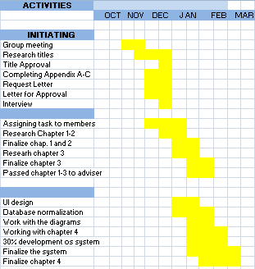

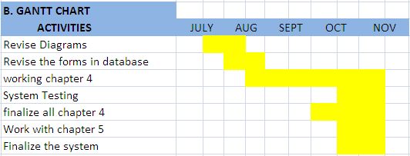

**Figure 3.Gantt Chart**

In the figure 3, shows the different detailed list of activities and accomplishments of the researchers with their work from the date it started until it finished. The month is also indicated to guide the researcher in accomplishing their work. The color yellow indicates when did they start and when did their work will be finished.

**Economic Feasibility**

Researchers determine the positive economic benefits that their proposed system will provide. It includes quantification and identification of all the benefits expected. They have used a cost/ benefits analysis.

Through economic feasibility, It helps to analyze the economics of the project of the researchers. This assessment goes beyond the items used by the researcher that is typically included in a financial analysis. Economic feasibility is interested in:

* economic benefits from the project
* economic costs of the project
* balance of these expressed in present value terms

**The Cost Benefit Analysis**

It summarizes the revenues and costs involved with the proposed project.  The amounts in the Cost Benefit Analysis reflect the amounts and assumptions and estimate the strengths and weaknesses of alternatives that satisfy transactions, activities or functional requirements of the researcher’s project.

**Hardware and Software Costs**

**I. Hardware Cost**

|  |  |  |
| --- | --- | --- |
| **Item** | **Quantity** | **Cost** |
| **Flash Drive(4 GB)** | **2** | **700.00** |
| **Packet Wifi** | **1** | **1, 400** |
| **Prepaid Card** | **1** | **500.00** |
| **Total: Php 2, 600.00** | | |

**II. Software Cost**

|  |  |  |
| --- | --- | --- |
| **Item** | **Quantity** | **Cost** |
| **PHP** | **N/A** | **Free Download** |
| **My SQL** | **N/A** | **Free Download** |
| **Cloud Server(web hosting)** | **N/A** |  |
|  |  |  |

**Total:**

**Stationeries and Supply**

|  |  |  |  |
| --- | --- | --- | --- |
| **Item** | **Quantity** | **Amount** | **Cost** |
| **Couponbond** | **135** | **1** | **135.00** |
| **Clip** | **6** | **4** | **24.00** |
| **Sliding Folder** | **10** | **8** | **80.00** |
| **Total: Php 239.00** | | | |

**Utility Expense**

|  |  |
| --- | --- |
| **Item** | **Cost** |
| **Electricity** | **150.00** |
| **Internet Expenses** | **150.00** |
| **Printing** | **336.00** |
| **Photocopy(Xeroxing)** | **284.00** |

**Total: Php 920.00**

**Summary of Cost**

|  |  |
| --- | --- |
| **Hardware Cost** | **Php 2,600** |
| **Software Cost** | **0** |
| **Stationeries and Supplies** | **Php239** |
| **Utilities Cost/ Expense** | **Php920** |
| **Other Expenses** | **0** |

**Total: Php 3,759**

**Cost and Benefit Analysis**

|  |  |  |  |  |  |
| --- | --- | --- | --- | --- | --- |
| **Discount Rate: 5 %** | | | | | |
| **Assume that the project in year 1** | | | | | |
|  | Year 1 | Year 2 | Year 3 | Year 4 | Total |
| Cost | 5000 | 4000 | 1000 | 1000 |  |
| Discount factor | 0.95 | 0.91 | 0.86 | 0.82 |  |
| Discount Cost | 4,750 | 3,640 | 860 | 820 | 10070 |
|  |  |  |  |  |  |
| Benefit | 50,000 | 100,000 | 100,000 | 100,000 |  |
| Discount factor | 0.95 | 0.91 | 0.86 | 0.82 |  |
| Discount Benefit | 47500 | 91,000 | 86,000 | 82,000 | 306,500 |
|  |  |  |  |  | 296,430 |
| Discount Benefit-Cost | 42,750 | 87360 | 85,140 | 81,180 |  |
| Cumulatative benefit-Cost | 37,750 | 83,360 | 84,140 | 80,180 |  |

**Formula**

**NPV=**Discount benefit –Discount cost

**NPV=**306,500-10070

**NPV=**296,430

**Return on Investment**

Formula: Total benefit- Total cost/ Total cost

Given: Total Benefit=306,500

Total Cost=10070

**ROI**=306,500-10070/10070

**ROI**=29.44%

**Requirements Modeling**

The Systems development life cycle (SDLC) is a conceptual model used in our project. This model describes the stages involved in an information system development project, from an initial feasibility study through maintenance of the completed application.

It also consists of input-process-output (IPO) model, also known as the IPO model, is a [functional model](http://en.wikipedia.org/wiki/Functional_model) and [conceptual schema](http://en.wikipedia.org/wiki/Conceptual_schema) of a general [system](http://en.wikipedia.org/wiki/System). An IPO chart/table identifies a program’s inputs, its outputs, and the processing steps required to transform the inputs into the outputs.

As shown in the figure 4, SDLC model the input shows the data regarding to all the information or personal data of the students of Bambang National High School needed in the enrollment, the problems encountered by the students, faculties and administrators in terms of enrollment process using their current enrollment process. It includes the advantages and its disadvantages. It involves also the different system design ideas in designing and developing the proposed system and the hardware and software requirements of the system.

The Process shows on how the to develop the system using the data and information obtain from the input. It shows the step by step way or process on how was the flow of work must be done in developing the system.

**Performance**

The different processes used are the following:

**Planning-** In this phase, developers planned what particular system is to be made and where it will be conducted. They observed and analyzed the problems encountered regarding in the current system and how the things to be done to solve problems.

**Analysis-** The student aims to develop the cloud based enrollment system. The project tries to improve the processing of enrollment in Bambang National High School.

**Design**-The developer consider the problems that may interfere system performances. It includes the logical and physical design of enrollment system.

**Testing-** The configuration of the devices, equipments, use in the system is done. The developers tested the compatibility, functions, performances and the specifications of the devices used in the enrollment system.

**Implementation-** Putting all devices in the respected area according to its plan.

**Maintenance-**The system administrator will be responsible in maintaining the system.

**Control**

In the system the researchers planned to make a quarterly status review and progress about users in how they use it, to make sure that the school that needs this system will surely get its desired outcome and also since this system is used once a year for enrolling purposes. Some of the things that must be checked are “databases”, “system reports if there is any failure in the writing process of the system”, “user interface improvement”, and many more. The researcher will process the change control through quarterly check-up for the system and when it is urgently needed.

**Risk Assessment/ Analysis**

Risk Assessment is the determination of quantitative or qualitative value of risk related to a concrete situation and a recognized threat. It helps the researchers to identify, evaluate, and estimate the levels of [risks](http://www.businessdictionary.com/definition/risk.html) involved in a situation, their comparison against [benchmarks](http://www.businessdictionary.com/definition/benchmark.html) or standards, and determination of an acceptable level of risk.

|  |  |  |  |  |
| --- | --- | --- | --- | --- |
| **Risk No.** | Vulnerability | Threat | Risk Summary |  |
| **1** | Hardware Issues/Equipment Failure or loss | System Unavailable | Inability to access the system. | Loss of hardware or equipment would result in the entire system or some portion of the system being unavailable. |
| **2** | Inadequate Customer Practices | Computer crime, malicious use, system compromise, unauthorized access |  | Data corruption or loss could result from improper or incomplete testing of system changes or system management /monitoring. |
| **3** | Environmental Issues | Loss of AC or power. |  | Environmental issues could result in the inability to access and maintain server hardware. |
| **4** | Natural Disaster | Hurricanes, floods, and other weather phenomenon. |  | Natural disasters could interrupt power to the Computer Center and make it impossible for staff to support the server environment thus disabling access to network. |

**Data and Process Modeling**

The researchers describes the data and process modeling concepts and tools they used in their system including data flow diagram, data dictionary and process descriptions .It analysis of data objects, other context that are used and the identification of the relationships among these data objects.

**Context Flow Diagram**

The diagram is a top level also known as Level 0. It only contains one process node (process 0) that generalizes the function of the entire Cloud Based Enrollment system in relationship to external entities.

**CONTEXT FLOW DIAGRAM**

STUDENT

ADMINISTRATOR

Register to enrollment form

Sectioning

Log-in

Print records

Confirm students

View Assessment Fees

***0***

***CLOUD BASED ENROLLMENT SYSTEM***

View

Student information

MASTER DATABASE

Figure

Dataflow Diagram

(Admin)

**Log-in to admin page**

**Input username and password**

**Log-in**

**Admin Successfully**

**Log-in?**

**no**

**yes**

**Display Admin page**

**Admin can modify and confirm student enrollee’s**

**Save changes before log-out**

**Log-out**

**Dataflow Diagram**

**(New Student)**

**START**

**Enrollment site**

**Fill-up forms**

**Submit student’s information**

**Consult Admin for Requirements**

**Dataflow Diagram**

**(Old Students)**

**Enrollment Site**

**Input ID number**

**Logged in?**

**Update existing information**

**Save Revision and Submit**

**Consult Admin for requirements**

Output and User-Interface Design

Home page of BNHS enrolment system



About page, were Mission and Vision of BNHS is indicated

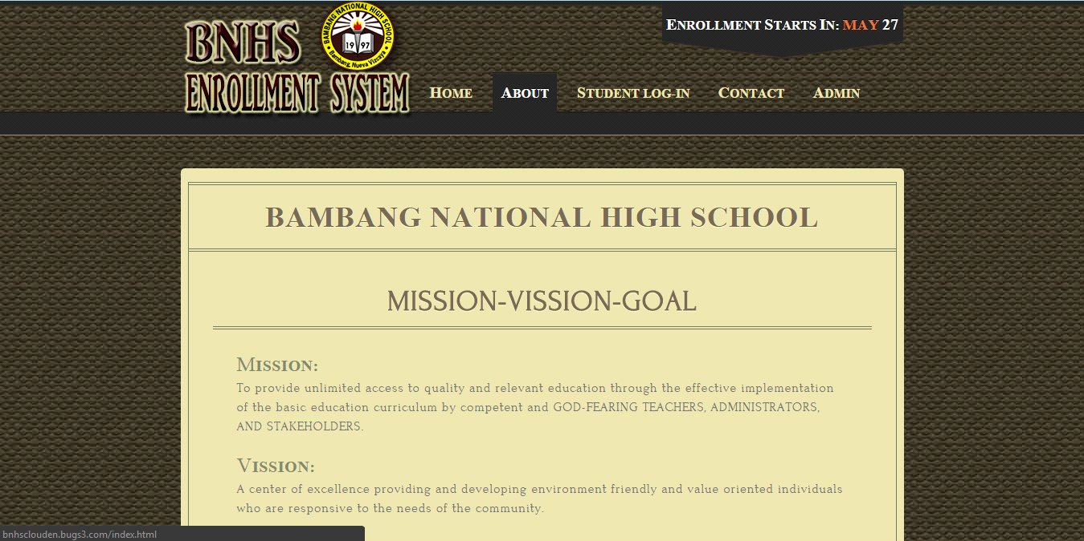

Contact page of BNHS enrolment system

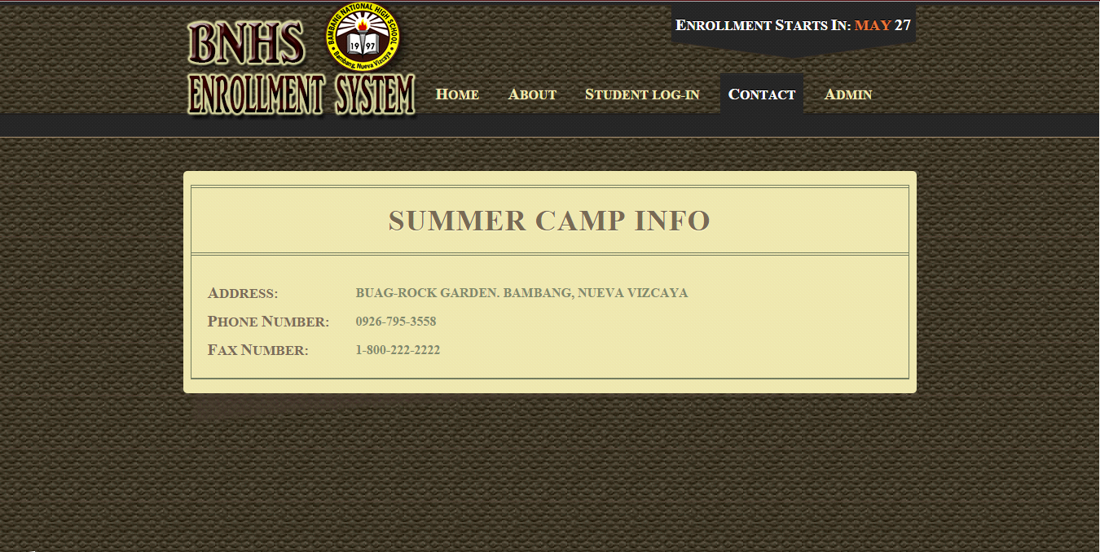

Student Log-in page of BNHS enrolment system

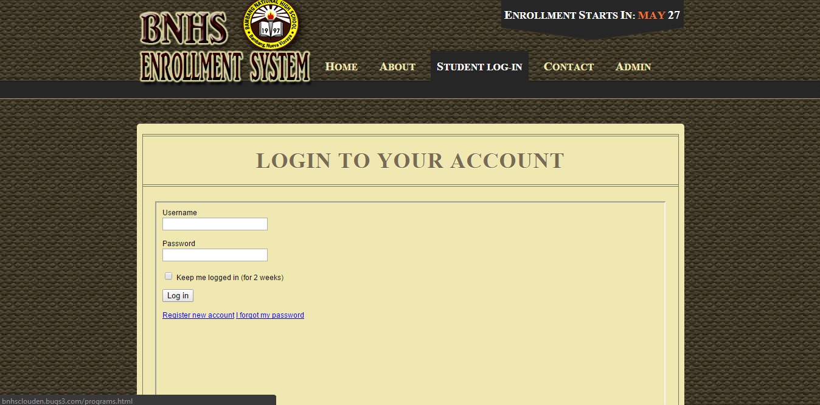

Registration page of BNHS Enrolment system

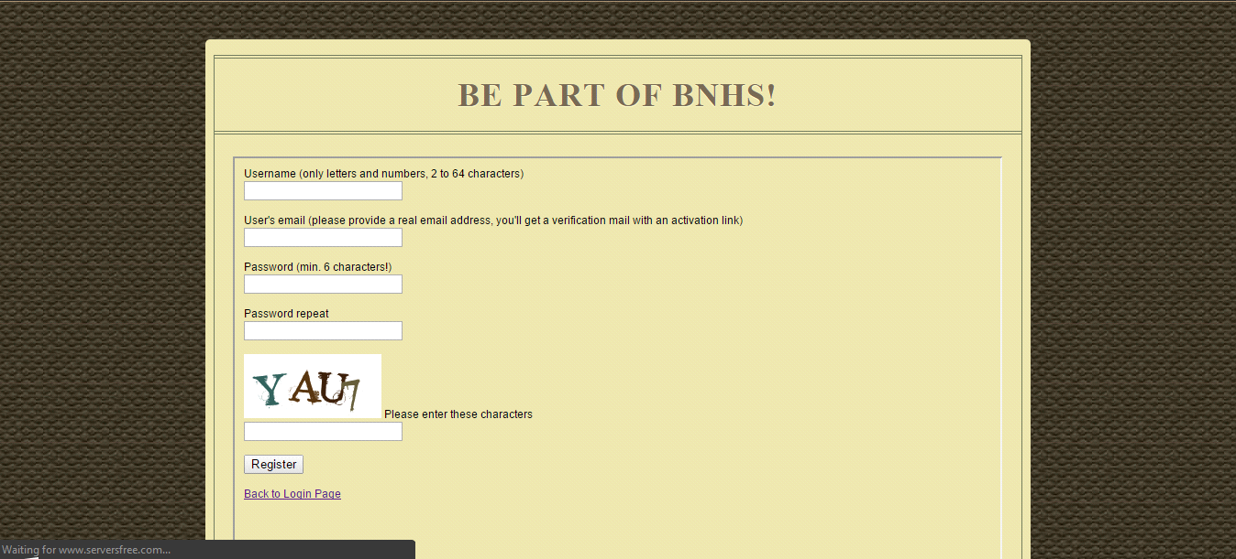

**Data Design**

The researchers used it to identify the data, define specific data types and storage mechanisms that producing a detailed [data model](http://en.wikipedia.org/wiki/Data_model) of a [database](http://en.wikipedia.org/wiki/Database).

**Entity Relationship Diagram**

The used of data model helps the researchers in describing the data or information aspects or its process requirements used in their system , in an abstract way that lends itself ultimately being implemented in a database such as relational database.

**Entity Relationship Diagram**

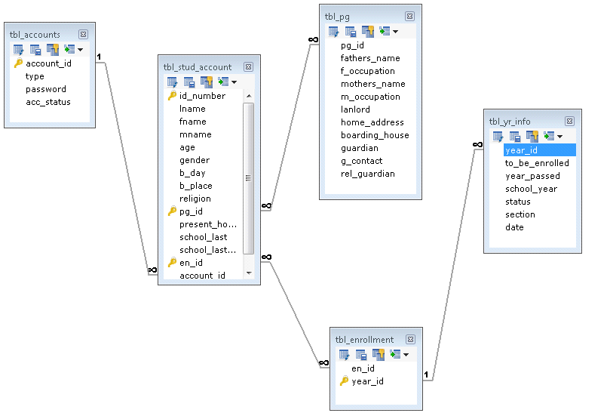

**Figure. Entity Relationship Diagram**

**Data Dictionary.**The  metadata repository, as defined in the IBM Dictionary of Computing, is a "centralized repository of information about data such as meaning, relationships to other data, origin, usage, and format.

**tbl_accounts**

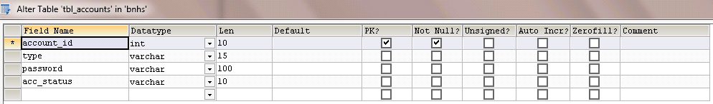

**tbl_enrollment**

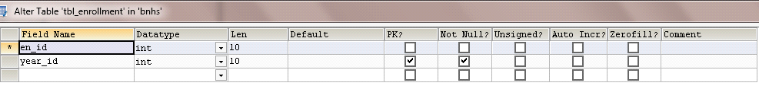

**tbl_pg**

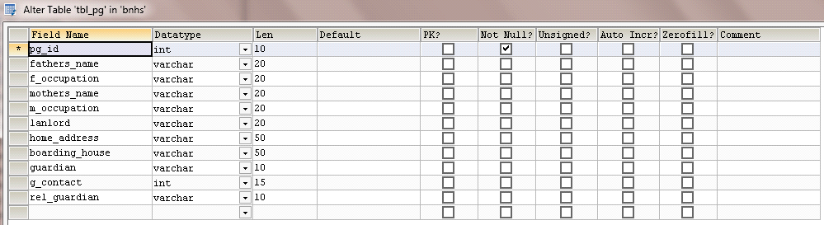

**tbl_stud_account**

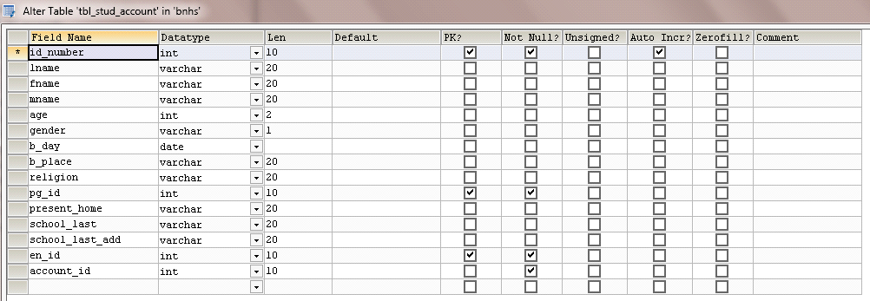

**System Architecture**

The [conceptual HYPERLINK "http://en.wikipedia.org/wiki/Conceptual_model"model](http://en.wikipedia.org/wiki/Conceptual_model) used by the researchers to define the [structure](http://en.wikipedia.org/wiki/Structure), [behavior](http://en.wikipedia.org/wiki/Behavior), and more [views](http://en.wikipedia.org/wiki/View_model) of their [system](http://en.wikipedia.org/wiki/System). An architecture description is a formal description and representation of a system, organized in a way that supports reasoning about the [structures](http://en.wikipedia.org/wiki/Structure) and [behaviors](http://en.wikipedia.org/wiki/Behavior) of the system.

**Network Model**

The network model is a database model conceived as a flexible way of representing objects and their relationships.

**Customer’s network**

**Customer isolated resources**

**Cloud(WEB) Services**

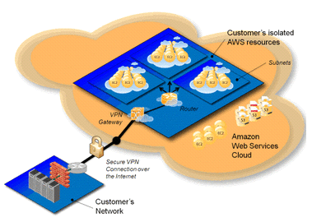

**Figure 5**

**Network Topology**

The network topology that is the researcher used is the star topology. A star topology is designed with each node such as file server, workstations, and peripherals that is connected directly to a central network hub, switch, or concentrator.





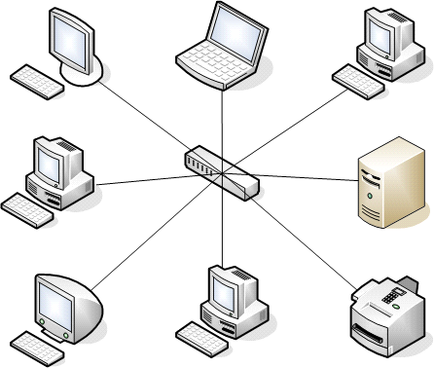

**Figure 6**

As shown in figure 6the different hardware such as the monitor, laptop, mobile devices and ipad that are connected to a network .They are used to access into the network.The hub, switch, or concentrator manages and controls all functions of the network. It also acts as a repeater for the data flow.

**Network Security**

It consists of the provisions and policies adopted by a network administrator to prevent and monitor unauthorized access, misuse, modification, or denial of a computer network and network-accessible resources

The system is equipped with the security of the cloud itself. Security is the degree of resistance to, or protection from, harm. It applies to any vulnerable and valuable asset, such as a person, dwelling, community, nation, or organization.

The researchers’ create password for the user’s protection in their personal data. It involves the email confirmation

Through Log-in form it identifies if the users can access the system. There is the separate Log-in form for the students and for the admin. The admin and the students have their own account to enter and their username and password will be modifying by the system through filtering.

**Development**

The Cloud Based Enrollment System is developed by the researchers by using hardware and software that is specifically designed to aid in the development of software and interfaces.

**Hardware and Software requirements**

The enrollment system consists of database server and application server. The database server needs to handle a vast amount of data, so a large volume data storage and good performance database management system is needed. The required hardware and software configuration is:

**Software Specification**

The Software application created is runnable and created through the following

Operating System: Requirements Specification

Windows 2007, 2008, 2010, XP

My Sql Database server Ultimate Edition

Wamp Server version 2.2a-x32

Notepad Notepad

Photoshop Photoshop CS4

Laptop (any Brand Name)

OS Windows 7

Processor Intel Core i3/Intel atom

Hard Disk Space At Least 1GB

Memory Capacity 2GB

Video Card 512MB or higher

OS Windows 8

Processor Intel Core i5

Hard Disk Space 1 GB to 4GB

Memory Capacity 2GB-4GB

Video Card 256MB or higher

OS Linux

Processor Dual Core

Hard Disk 500GB

Memory capacity 2GB

**Hardware Specification**

**Desktop**

System Unit Memory Capacity

Hard Disk Space

Processor

Video card

Monitor SVGA Monitor(600-800 and 32 bit)

Mouse Scroll ball or optical mouse

Keyboard Standard Keyboard

Flashdrive 4GB to 8GB

Packet Wifi 4GB

**Program Specification**

Programming Languages

HTML

PHP-Version 5.5

MySQL Database-Solyog (Ultimate Edition)

CSS or Cascading Style Sheet

**Programming Environment**

The researcher used the web programming technique and database normalization. Though Environment Setup is not an element of any Programming Language, it is the first thing researchers need to start programming with any Programming Language.

In Environment Setup, it simply means they need to have a base on top of which they can do programming. Thus, they need to have required software setup, such as installation on PC which will be used to write Computer Program, compile and execute it. In browsing the internet, they need the following setup on machine:

* A working Internet Connection to connect to the Internet.
* Web Browser like Internet Explorer, Chrome, or Safari, etc.
* A text editor to create computer program.
* A compiler to compile program into binary format.
* An interpreter to execute program directly.

The Software, which will be used to write computer program. The windows machine must have a Notepad, which can be used to type program. The researcher write computer program using programming language.

This is required in to write program in a programming language, which needs compilation into binary format before its execution used by the researchers such programming languages CSS, Html. They use also the PHP which do not need any compilation into binary format, rather an interpreter can be used to read such program line by line and execute it directly without any further conversion.

**Front End**

The researchers [interface](http://en.wikipedia.org/wiki/Interface_(computer_science)) of their system between the user and the back end. The graphical user interface (GUI) acts as a front end desktop environment instead.

Google Chrome or Firefox, browsers used by the researchers to translates all of the code in a manner for users/clients to see and with which to interact, such as fonts, colors, drop-down menus, sliders, forms, etc. They used the Photoshop to edit pictures such as the logo that will serve as their design to their enrollment website.

The log in forms design for the students/admin to input their username and password with the font styles, size and its font color.The enrollment form design with the textboxes where in the student will enter all their information.

The researchers created submit button for the students to save their information and confirm button for the admin for the confirmation of the students in their enrollment as well as the print button used also to print the students’ records.

The design is develop using the HTML, CSS for the front end of the enrollment website.

**Back End**

A back-end database is a [database](http://en.wikipedia.org/wiki/Database) that is accessed by users indirectly through an external [application](http://en.wikipedia.org/wiki/Application_software) rather than by application programming stored within the database itself or by low level manipulation of the data through SQL commands.

The users enters all of his or her information, such as their name, address, all information about him/her in an enrollment website and Log-in in a log in form, the web application stores the information in a database that was created previously on the server in which the website is calling for information. The researchers used MySql to save students information in a database server.

The researchers used WEB server so that it will be accessed remotely by the computer that runs software to fulfill requests from their clients. In short, when a students and admin enter their information needed the backend operation is the web application communicating with the server to make a change in a database stored on said server. Technologies like PHP, Bootstrap the ones backend use by the researchers to make the communication work smoothly, allowing the students and admin process their information needed during the enrollment process.

**Deployment Diagram**

Deployment diagrams are used to visualize the topology of the physical components of a system where the software components are deployed. It used to describe the static deployment view of a system. Deployment diagrams consist of nodes and their relationships.

**<<device>>**

**Cloud Server(web hosting)**

**<<device>>**

**Terminal**

**<<device>>**

**Database Server**

**<<device>>**

**WampServer**

**MysqlSercver**

**Online.jar**

**Figure 7. Deployment Diagram**

In the figure 7 it shows in the system, the model the of physical aspect of database is being used that is being utilize in a cloud as a service .It models the run-time configuration in a static view and visualizes the distribution of components in an application such as the online.jar that is created in the Wamp Server using mysql server. Most cases, it involves modeling the hardware configurations together with the software components that lived on.

**Test Plans**

After the system has been made, the researchers conducted the test plans that will ensure the system meets its desired quality. And because the research project composes of enrollment system they focus on how it will perform during on the actual enrollment process, through determining bugs, redundancy of data etc. Through production test that they have made, they divided the test strategy into two which is the beta test testing and the alpha testing.

* Beta Testing- composes of the preliminary testing of the different functions of the system, such as testing the student enrollment fill up forms etc. to remove the data redundancy that was seen from the system.
* Alpha Testing- is the continuation of the beta testing, it composes system verification with the community itself, and again checking the reports generated for better performance.

**Test Data**

**Database fields**

The researchers test the databases, they test some boundary cases and repeating cases. They enter all possible inputs, and test whether the system gives the expected response for the corresponding input. For example, there will be a system message to show the success of the enrollment process if the user enters all input correctly. On the other hand, if the user enters any incorrect field, the system will pop up a message to show which field has been input incorrectly.

The researchers identify different activities involved in their system. In terms of enrolling the student, it will include the following activities such as student will first register in a registration form, the username and password has been used with the correct data types, required length in a database. As the student input their information it will accept those data according to the required field type that is being put into the database.

.

**Verification, Validation, Testing**

**Stress**

The researchers used this performance to test and determine their application’s robustness, availability, and reliability under extreme conditions. It helps them to identify application issues that arise or become apparent only under extreme conditions.

**Compatibility testing**

Testing conducted by the researchers on their [application](http://en.wikipedia.org/wiki/Application_software) to evaluate the application's [compatibility](http://en.wikipedia.org/wiki/Computer_compatibility) with the computing environment. It can be of two types - forward compatibility testing and backward compatibility testing. Computing environment may contain some or all of the below mentioned elements:

* Operating systems ([Linux](http://en.wikipedia.org/wiki/Linux), [Windows](http://en.wikipedia.org/wiki/Microsoft_Windows), [Mac](http://en.wikipedia.org/wiki/Mac_OS) etc.)
* [Database](http://en.wikipedia.org/wiki/Database) (Oracle, SQL Server, MySQL, etc.)
* Other System Software (Cloud Server)
* [Browser](http://en.wikipedia.org/wiki/Web_browser) compatibility (Chrome, Firefox, Netscape, Internet Explorer, Safari, etc.)

**Load testing**

The researchers used to test the load that can be the expected on concurrent number of users on the [application](http://en.wikipedia.org/wiki/Application_software) performing a specific number of [transactions](http://en.wikipedia.org/wiki/Transaction_processing) within the set duration. Since the system is uploaded through cloud storage which composes of super computers, it can hold the maximum expectation the population of BNHS.

**Functions that are tested:**

|  |  |
| --- | --- |
| **Functions for Load Test** | **Comment** |
| Student Data gathering form | Fast |
| Administrators Functions(Modify and edit) | Moderate |
| Students Data Printing | Fast |

The researchers identify the performance acceptance criteria in terms of

* **Response time.** Through opening the site of enrollment it will run smoothly in any browsers like Google chrome and Mozilla Firefox.
* **Throughput.**   The researchers system supports 1000 students who will access and use the system.

Unit testing

Integration Testing

**System Testing**

Sanity test, Installation test, Functional test, Security test, Usability test, Performance test, Regression test, Performance testing and the requirements of the system

The system is runnable in browser like Mozilla firefox, google chrome, and safari for ipad. As the proponent test its function the system responds fast to the following browsers. The system will quick respond depend in the net performance (fast internet).

**Chapter V**

**Conclusions, Recommendations and Implementation Plan**

**Conclusion**

It is stated that the enrollment system utilizing the cloud is more reliable, faster in terms of registration of the student during enrollment, more efficient and user friendly than the existing enrollment system. The developed system features in managing enrollment to old and new students

The system will help to aid the problems encountered by the administrators and faculties during the existing enrollment system. The system will also benefit the student by saving their time and for administrators to lessen their workloads.

**Recommendation**

The researcher’s several recommendations are the following:

1.For future researchers a conduct to similar study is encouraged and can add additional scope to the system.

2. If slow internet connection occurs, the school should used

3. The system unit to be used is placed to secured areas and convenient environment that is accessible to the administrators

4. For emergency cases like brownout, the school will use their existing manual system.

**Implementation Plan**

The Cloud Based Enrollment System will be implemented in Bambang National High School. The system will be managed by the school administrators and be place in their office and also the student will benefited using their Laboratory.

**Project Implementation Checklist**

**Implementation Contingency**

**Infrastructure/Deployment**

Cloud Based Enrollment System will be deploying in Bambang National High School. Its server will be place in admin office and will be manage by administrator.

The students will be able to access the system through the internet or using the Computer laboratory.

**Bibliography**

**A. Published Materials**

**B. Unpublished Materials**

**C. Website Sources**

<http://www.cmlab.csie.ntu.edu.tw/~freetempo/CN2011/hw/hw1/p50-v39n1l-vaqueroA.pdf>

<http://www.webhostingspree.com/cloud/resources/key-features/>

<http://www.mcu.edu.ph/stag/wp-content/uploads/2013/12/MCU_-the_-K_to_-12_-Curriculum.pdf>

**APPENDIX “A”**

Bambang approval letter

APPENDIX “B”

THESIS ADVISER

APPENDIX “C”

COPY OF THESIS ADVISER

APPENDIX “D”

INTERVIEW QUESTIONNAIRE

* What is the process of your enrollment?
* What problems do you encounter during enrollment season?
* What is the problem of the student during enrollment?
* How will you able to manage enrollment of lot of students?
* What are the possible solutions that school addresses during enrollment?
* Who is the one who is managing the enrollment?
* What do you think is the benefit if we use a system that will help the enrollment of the student fast?
* What are the advantages of using your traditional way of enrollment?
* What are the disadvantages of using your traditional way of enrollment?

APPENDIX “E”

EVALUATION TOOL

APPENDIX “F”

NORMALIZATION

*Fields and tables*

dbname

Appendices

* Relevant Source Code
* Evaluation tool
* Sample Input/ Output Reports

APPENDIX “G”

ENTITY RELATIONSHIP DIAGRAM(ERD)

APPENDIX “H”

Data dictionary

The data dictionary contains the fields which are the information needed in the database that determines what type of data are needed in order that the computer can understand it.

APPENDIX “I”

DATABASE SCHEMA

The database schema

Database name

APPENDIX “J”

CONTEXT FLOW DIAGRAM(CFD)

APPENDIX “K”

DATAFLOW DIAGRAM(DFD)

APPENDIX “L”

FLOWCHART OF THE SYSTEM

STUDENTS

APPENDIX “M”

FLOWCHART OF THE SYSTEM

ADMINISTRATOR

**APPENDIX “N”**

**USER’S MANUAL**

PREFACE

This system was developed by the researchers to improve the current system of Bambang National High School, Bambang Nueva Vizcaya.

With the Cloud Based Enrollment System, enrollment will be improve and produce user friendly, faster and more accurate enrollment system.

INTRODUCTION

System Requirements

a. Hardware

b. Software

**FORMS**

**LOGIN FORMS**

**MAIN FORM**

**COMMAND BUTTON**

**HOME**

Student visit and view the enrollment website of the school.

**ABOUT**

Student will view the vision and mission and relevant information of the school

**CONTACT**

Contact number of school and its email address is indicated where students will be able to contact the school whenever there is a problem.

**Log in form**

The student will enter valid username and password to enter in the system.

**Enrollment Form**

The student will fill up the form by their personal information.

**Log-out form**

The student will now exit the system.

**Assessment Form**

The student will be able to view all the assessment fees of the school.

**REPORTS**

Alona Mae V. Vargas

09366536242

[alonamaevargas@yahoo.com](mailto:alonamaevargas@yahoo.com)

**Personal Background**

Address :Parae, Dupaxdel Norte BuevaVizcaya

Date of Birth : January 26, 1992

Citizenship : Filipino

Father’s Name : Jornald A. Vargas Occupation : Farming

Mother’s Name : Gemma V. Vargas Occupation : Housewife

**Educational Background**

***Tertiary Level***

Bachelor of Science and Information Technology

Nueva Vizcaya State University, Bambang Campus

Bambang, Nueva Vizcaya

Year 2015

***Secondary Level***

Munguia National High School

Munguia, Dupax del Norte, Nueva Vizcaya

Year

***Elementary Level***

Parae Elementary School

Parae,Dupax del Norte, Nueva Vizcaya

Year 2007

**SEMINARS/TRAINING/WORKSHOP ATTENTED**

* **TECHNOLOGY DAY CELEBRATION 2012 “DIGNIFYING THE BLUE COLLAR OCCUPATION”**

NVSU, Bambang, Nueva VIzcya

February 16, 2012

* **LEVERAGING KNOWLEDGE FOR ADVANCEMENT THROUGH INFORMATION TECHNOLOGY”**

SMU,Bayombong, Nueva Vizcaya

January 25, 2013

* **ROBOTICS TODAY AND TOMORROW**

NVSU, Bambang Nueva Vizcaya

March 5, 2014

* **RADIO FREQUENCY IDENTIFICATION:LATEST IN AUTOMATIC DATA CAPTURE TECHNOLOGY**

NVSU, Bambang, Nueva Vizcaya

March 5, 2014

Raymund L. Cuaresma

09396465782

**Personal Background**

Address :Punawa, Jewel Subdivision Bambang, Nueva Vizcaya

Date of Birth :May 30, 1994

Citizenship : Filipino

Father’s Name :Rogelio L. Cuaresma Occupation :Part time

Mother’s Name :Eugenia L. Cuaresma Occupation :OFW

**Educational Background**

***Tertiary Level***

Bachelor of Science and Information Technology

Nueva Vizcaya State University, Bambang Campus

Bambang, Nueva Vizcaya

Year 2015

***Secondary Level***

Year

***Elementary Level***

Year

**SEMINARS/TRAINING/WORKSHOP ATTENTED**

* **TECHNOLOGY DAY CELEBRATION 2012 “DIGNIFYING THE BLUE COLLAR OCCUPATION”**

NVSU, Bambang, Nueva VIzcya

February 16, 2012

* **LEVERAGING KNOWLEDGE FOR ADVANCEMENT THROUGH INFORMATION TECHNOLOGY”**

SMU,Bayombong, Nueva Vizcaya

January 25, 2013

* **ROBOTICS TODAY AND TOMORROW**

NVSU, Bambang Nueva Vizcaya

March 5, 2014

* **RADIO FREQUENCY IDENTIFICATION:LATEST IN AUTOMATIC DATA CAPTURE TECHNOLOGY**

NVSU, Bambang, Nueva Vizcaya

March 5, 2014

* **WORKSHOP ON WEB PROGRAMMING USING MODEL-VIEW-CONTROLLER FRAMEWORK**

NVSU, Bambang, Nueva Vizcaya

November 5, 2014

Emmanuel D. Soriano

09267953558

**Personal Background**

Address :Munguia, Dupax Del Norte, Nueva Vizcaya

Date of Birth :

Citizenship : Filipino

Father’s Name : Occupation :

Mother’s Name : Occupation :

**Educational Background**

***Tertiary Level***

Bachelor of Science and Information Technology

Nueva Vizcaya State University, Bambang Campus

Bambang, Nueva Vizcaya

Year 2015

***Secondary Level***

Year

***Elementary Level***

Year

**SEMINARS/TRAINING/WORKSHOP ATTENTED**

* **TECHNOLOGY DAY CELEBRATION 2012 “DIGNIFYING THE BLUE COLLAR OCCUPATION”**

NVSU, Bambang, Nueva VIzcya

February 16, 2012

* **LEVERAGING KNOWLEDGE FOR ADVANCEMENT THROUGH INFORMATION TECHNOLOGY”**

SMU,Bayombong, Nueva Vizcaya

January 25, 2013

* **ROBOTICS TODAY AND TOMORROW**

NVSU, Bambang Nueva Vizcaya

March 5, 2014

* **RADIO FREQUENCY IDENTIFICATION:LATEST IN AUTOMATIC DATA CAPTURE TECHNOLOGY**

NVSU, Bambang, Nueva Vizcaya

March 5, 2014

* **WORKSHOP ON WEB PROGRAMMING USING MODEL-VIEW-CONTROLLER FRAMEWORK**

NVSU, Bambang, Nueva Vizcaya

November

**LIST OF TABLES**

Tables Description Page

No.

**1.**

**LIST OF FIGURES**

Figure Description Pages

No

**EVALUATION TOOL**

The proponents use means to determine the output of the system performance. The respondents are involved to measure if the system will passed or fail with its desired function.

**Mean Ratings of the Respondent on their Perception of the Proposed system in Terms of accuracy**

|  |  |  |
| --- | --- | --- |
| **Cloud Based Enrollment System Related Task** | **Mean** | **Description** |
| **ACCURACY** |  |  |
| 1. The system accurately checks the information of the students inputted by the user | **4.57** |  |
| **2.** The system checks the students who has enrolled | **4.55** |  |
|  |  |  |

**Reliability**

**Mean Rating of the Respondents on their Perception of the Proposed System in Terms of Reliability**

|  |  |  |
| --- | --- | --- |
| **Cloud Based Enrollment**  **System Related Task** | **Mean** | **Description** |
| **RELIABILITY** |  |  |
|  |  |  |
|  |  |  |

**SPEED**

**Mean Rating of the Respondents on their Perception of the System in Terms of Speed**

|  |  |  |
| --- | --- | --- |
| **Cloud Based Enrollment Sytem Related Task** | **Mean** | **Description** |
| **SPEED** |  |  |
|  |  |  |
|  |  |  |
|  |  |  |

**Efficiency**

**Mean Rating of the Respondents on their Perception of the Proposed System in Terms of Efficiency**

|  |  |  |
| --- | --- | --- |
| **Cloud Based Enrollment Sytem Related Task** | **Mean** | **Description** |
| **EFFICIENCY** |  |  |
|  |  |  |
|  |  |  |
|  |  |  |

**User friendliness**

**Mean Rating of the Respondents on their Perception of the Proposed System**

**in Terms of User-Friendliness**

|  |  |  |
| --- | --- | --- |
| **Cloud Based Enrollment Sytem Related Task** | **Mean** | **Description** |
| **USER FRIENDLINESS** |  |  |
| The system is easy to use and understand |  |  |
|  |  |  |
|  |  |  |
|  |  |  |

**Summary of Respondents’ Perception on the Use of the Proposed Cloud Based Enrollment System**

|  |  |  |
| --- | --- | --- |
| **Cloud Based Enrollment System Related Task** | **Mean** | **Description** |
| Accuracy |  |  |
| Reliability |  |  |
| Speed |  |  |
| Efficiency |  |  |
| User Friendliness |  |  |
| **Total Weighted Mean** |  |  |

**System testing**

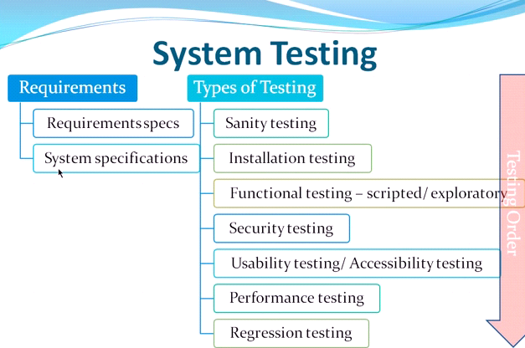

form log in to the Log-in form, as they click the log-in form it will respond automatically and runs to its preferred function like

**APPENDIX N**